MCKV INSTITUTE OF ENGINEERING

Computer Science and Engineering – Data Science

***Name - Abhinaba Sarkar***

***Roll No. - BTECH/CSE-DS/2020/47***

**Assignment Number: *6***

Problem statement:

Write a python program to find out the largest and smallest element from a 1D list.

Assignment 6.a)

Source code:

[FOR 1D ARRAY]

arr1d = []

num = int(input("No. of elements :"))

for n in range(num):

numbers = int(input("Enter numbers :"))

arr1d.append(numbers)

print("Largest element : ", max(arr1d), "\nSmallest element : ", min(arr1d))

output:

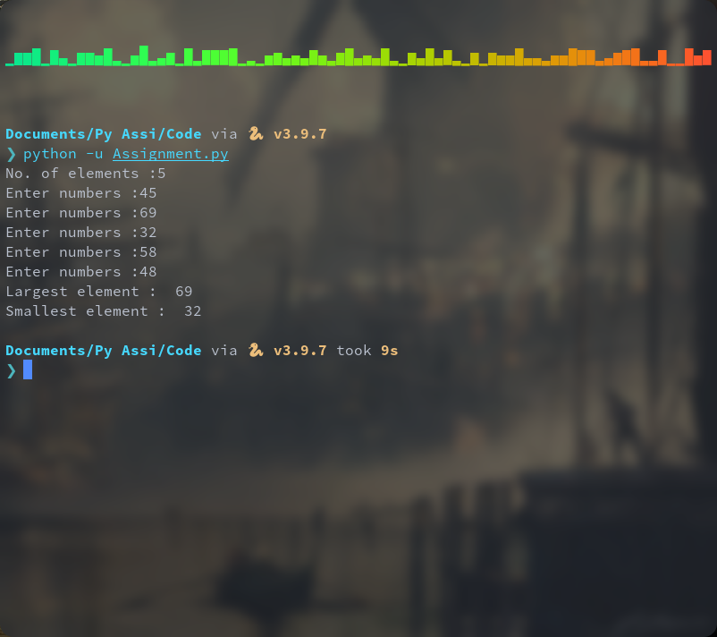

Problem statement:

Write a python program to find out the largest and smallest element from a 2D list.

Assignment 6.a)

Source code:

[FOR 2D ARRAY]

r=int(input("Enter the row size:"))

c=int(input("Enter the column size:"))

matrix=[]

for i in range(r):

a=[]

for j in range(c):

a.append(int(input("Enter Elements:")))

matrix.append(a)

max=matrix[0][0]

min=matrix[0][0]

for i in range(r):

for j in range(c):

if matrix[i][j]>max:

max=matrix[i][j]

if matrix[i][j]<min:

min=matrix[i][j]

print("largest element:", max ,"\nsmallest element:", min)

output:

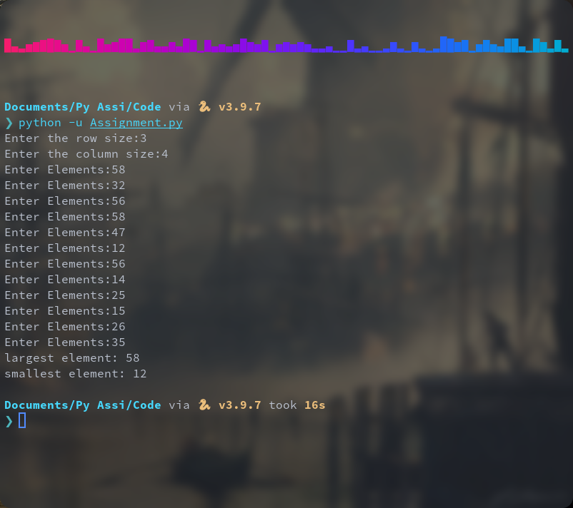

Problem statement:

Remove all the duplicate element from a list.

Assignment 6.b)

Source code:

list1 = []

a=int(input("The no of elements: " ))

for j in range(a):

elements=int(input("input:"))

list1.append(elements)

res = []

for i in list1:

if i not in res:

res.append(i)

print ("The list after removing duplicates : " + str(res))

output:

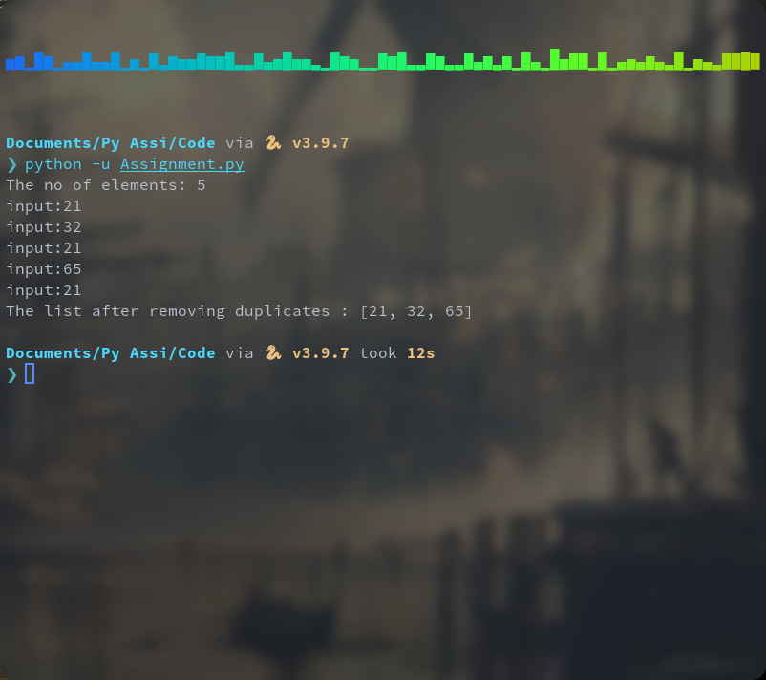

Problem statement:

Take 2 multiplication compatible matrices as input and show the result of multiplication in matrix format.

Assignment 6.c)

Source code:

A = [[1, 2, 3],

[3, 2, 1],

[1, 2, 3]]

B = [[1, 1, 1, 1],

[2, 2, 2, 2],

[3, 3, 3, 3]]

result = [[0, 0, 0, 0],

[0, 0, 0, 0],

[0, 0, 0, 0]]

for i in range(len(A)):

for j in range(len(B[0])):

for k in range(len(B)):

result[i][j] += A[i][k] * B[k][j]

for r in result:

print(r)

output:

